**Sprint 2**

Eden Dadon - 207279183

Avihay Maman - 205506413

Nofar Elbaz - 316580562

Dudi Biton - 314963141

**Links:**

* Clubhouse - <https://app.clubhouse.io/invite-link/604f752a-93cf-4c19-b570-944bd684cd59> (Invitation links were sent to the lecturer and facilitator).
* Github - <https://github.com/edenvvv/Projects-Management>
* Our website - <https://projects-management-ade.herokuapp.com/>

**Explanation of Part 2:**

In the project we decided to use the following tools:

* 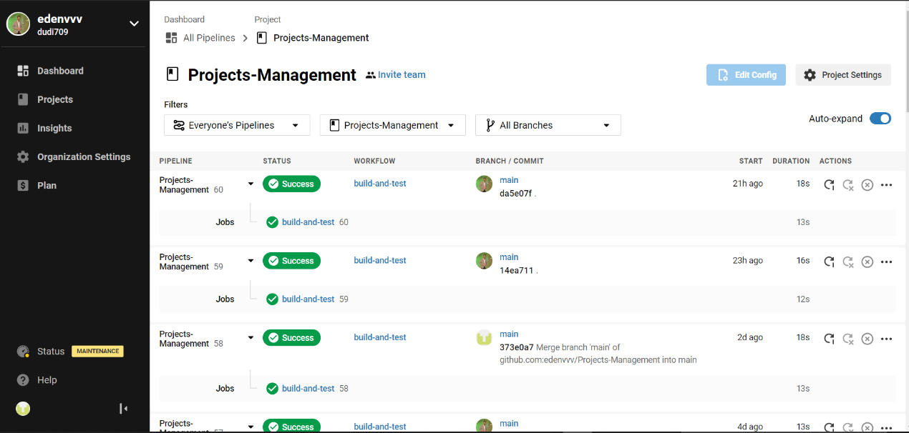For CI / CD we use the circleci tool
* 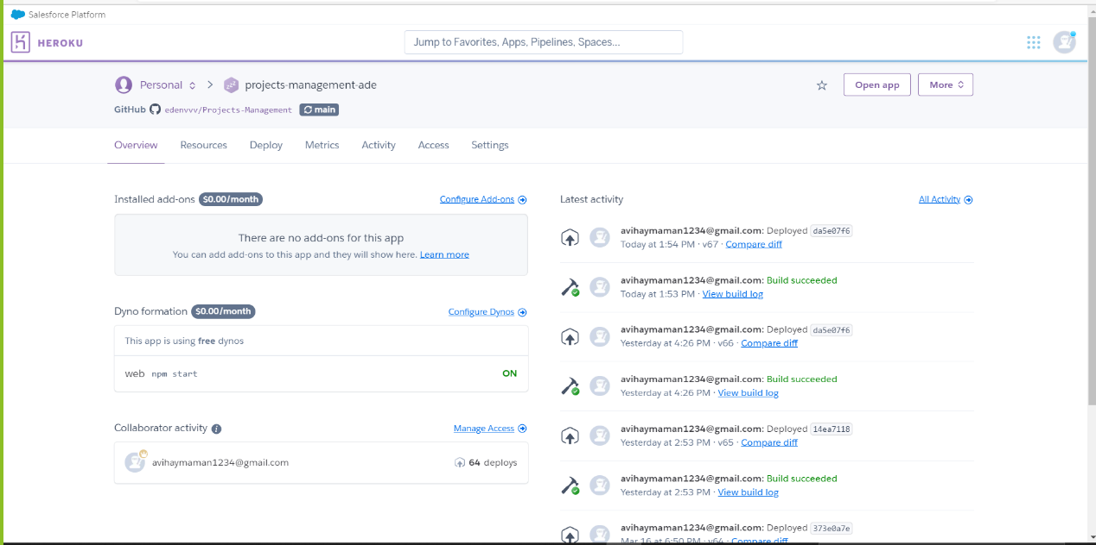For the CLOUD service for storing and running the project, we chose Heroku (<https://projects-management-ade.herokuapp.com/>)
* 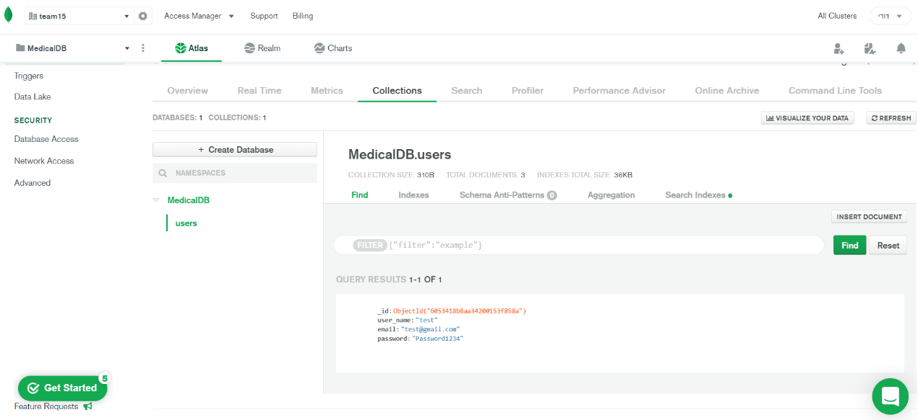For saving the data we chose mongoDB

**Functional requirements:**

1. The doctor user will have a page with all his details.
2. The doctor user would be able to see his appointments records.
3. The simple user would be able to search for doctors using free text search box.
4. The simple user would be able to filter the results (you should give at least 3 filter options).
5. The simple user would be able to sort the results (you should give at least 3 sorting options).
6. The simple user would be able to rank the satisfaction level of the doctor after this appointment is over (from 1 to 5)
7. The doctor user would be able to send appointment summery to his clients at the end of the appointment.
8. The simple user would be able to see his appointments records.
9. The simple user would be able to book appointments only to doctors who offer services to his clinic.
10. The simple user would be able to see the appointments summery of all his appointments.
11. The simple user would be able to post reviews on the doctor’s private page.
12. The doctor’s reviews would be public to all.
13. The simple user would be able to send his contact information and a note to doctors privately.
14. The doctor user would be able to open public forums where he could answer questions.
15. The admin user would be able to authorize doctor users via email.
16. . The doctor user would be able to delete questions from the forum and manage it at his convenience.
17. The admin user would be able to authorize the new forums after he revied them.
18. The simple user would be able to make appointments only in available time.

**made by us**:

1. The company logo will navigate to home page.
2. The website contains same footer for each page.
3. There will be a back button at the beginning of the home page.
4. The navigation bar will remain on the screen for all over the website.

**Non-functional requirements:**

**made by us**:

1. The system will be secured using the SSL protocol (Quality: Integrity).
2. Adjusting the system for both the computer and the mobile device (Quality: Flexibility).
3. The system will have incredible user experience (Quality: Flexibility)
4. The system will run on any of the popular browsers (Chrome, Safari, Firefox etc.) (Quality: Flexibility).

|  |  |
| --- | --- |
| **Sprint 3 – 60%** | **Sprint 4 – 40%** |
| Requirement No. 1 | Requirement No. 11 |
| Requirement No. 2 | Requirement No. 12 |
| Requirement No. 3 | Requirement No. 13 |
| Requirement No. 4 | Requirement No. 14 |
| Requirement No. 5 | Requirement No. 15 |
| Requirement No. 6 | Requirement No. 16 |
| Requirement No. 7 | Requirement No. 17 |
| Requirement No. 8 | Requirement No. 18 |
| Requirement No. 9 | Requirement No. 19 |
| Requirement No. 10 | Requirement No. 20 |
| Requirement No. 21 |  |
| Requirement No. 22 |  |
| Requirement No. 23 |  |
| Requirement No. 24 |  |
| Requirement No. 25 |  |
| Requirement No. 26 |  |

**Division of requirements for sprints**